TERRAFORM TASK -06
2.Execute the script shown in the video.
- Open VS Code and create a project folder: TERRAFORM_PROJECT
- Inside it, create a folder named aws_instance
- Inside aws_instance, create these files:
  - main.tf
  - variables.tf
- In main.tf, write the EC2 resource block and use variable for AMI:
  - ami = var.ami
  - instance_type = "t3.micro"
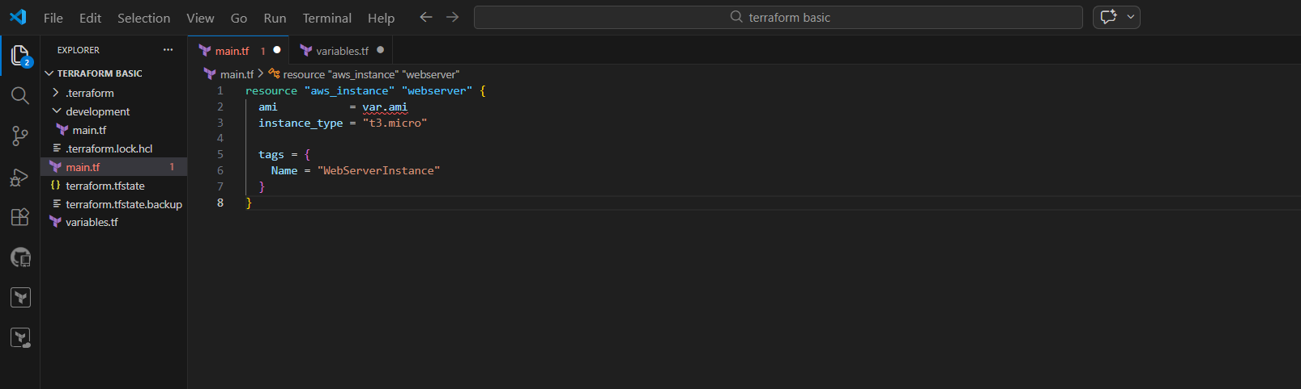

- Open aws_instance/variables.tf
- Create a variable for AMI like:
  - variable "ami" { }
- Save the file

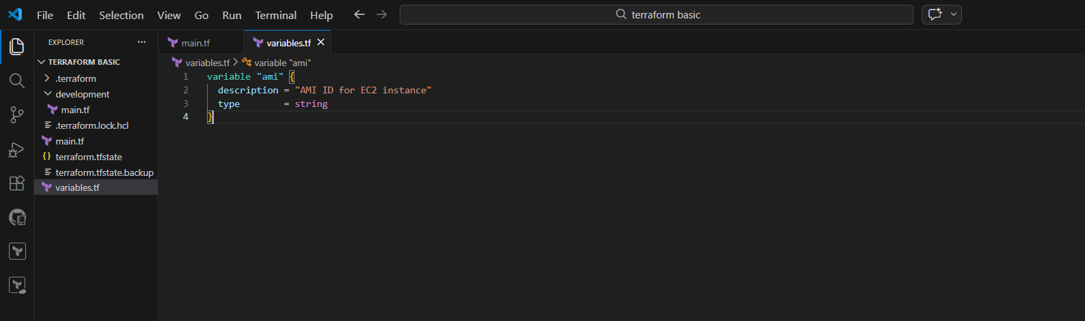
- Create a new folder in project: development
- Inside development, create main.tf
- In development/main.tf, call the module:
  - module "dev-webserver" {
  - source = "../aws_instance"
  - ami = "ami-xxxxxxxxxxxx"
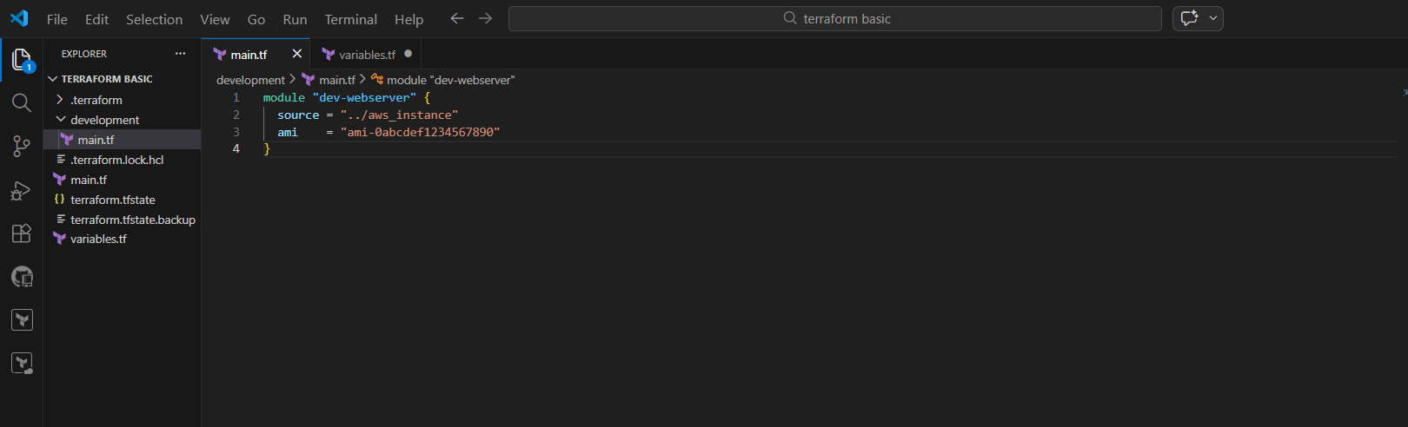
- Open terminal in VS Code
- Go to development folder:
- cd .\development\
- Run Terraform initialization:
- terraform init
- Confirm message: Terraform has been successfully initialized
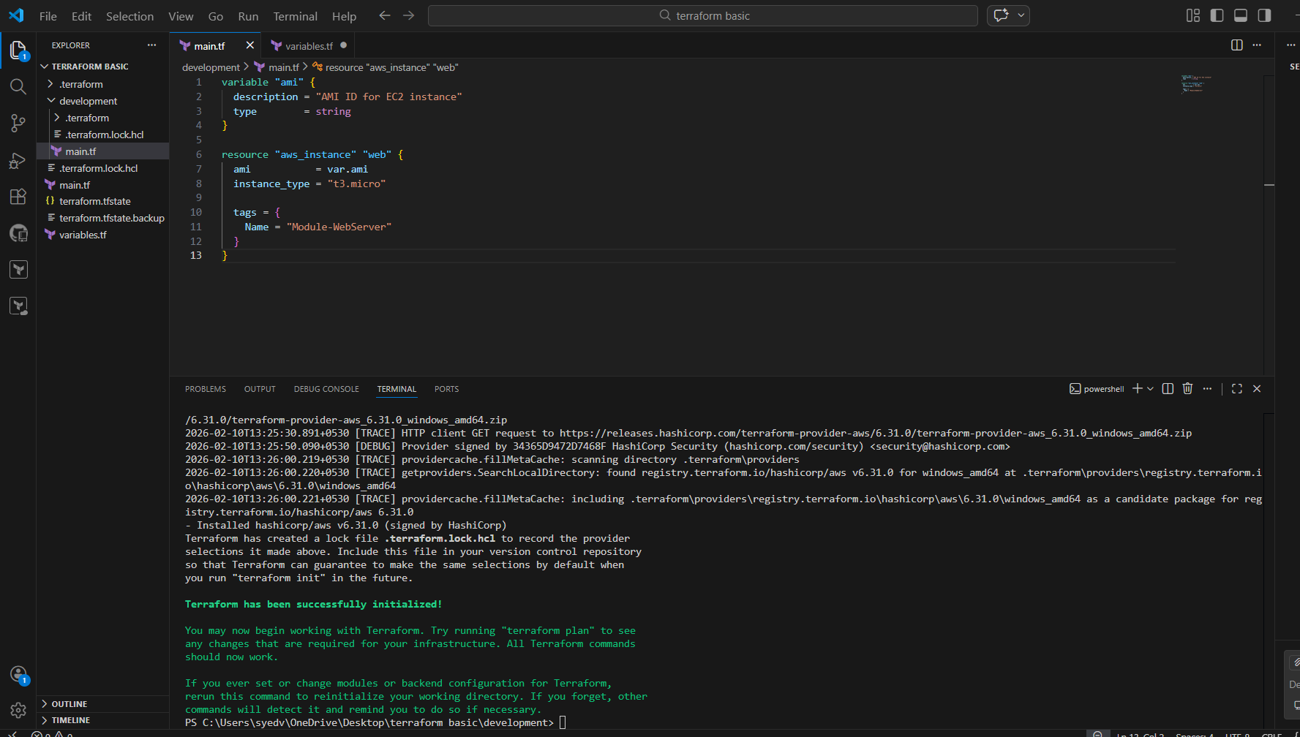
- Run Terraform apply:
- terraform apply
- Review plan: Plan: 1 to add, 0 to change, 0 to destroy
- Type:
- yes
- Wait until it shows Creation complete
Instance is successfully created
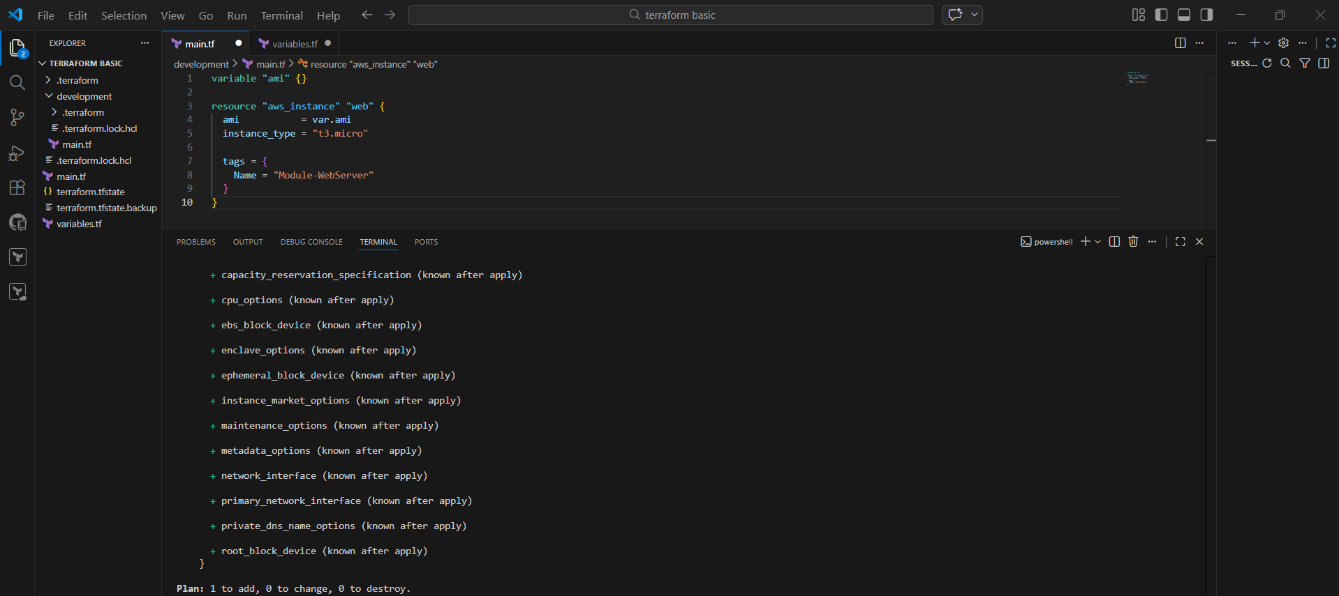
- Open AWS Console
- Go to EC2 → Instances
- Check your instance state is Running
- Verify AMI ID and Instance Type (t3.micro)
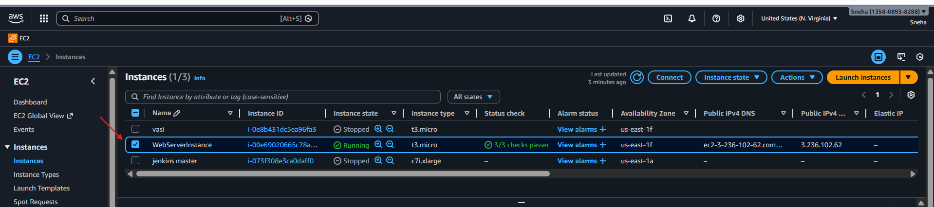
- In terminal (project root), create new workspace:
terraform workspace new projectA
- List workspaces:
terraform workspace list
- Switch workspace:
terraform workspace select default
terraform workspace select projectA
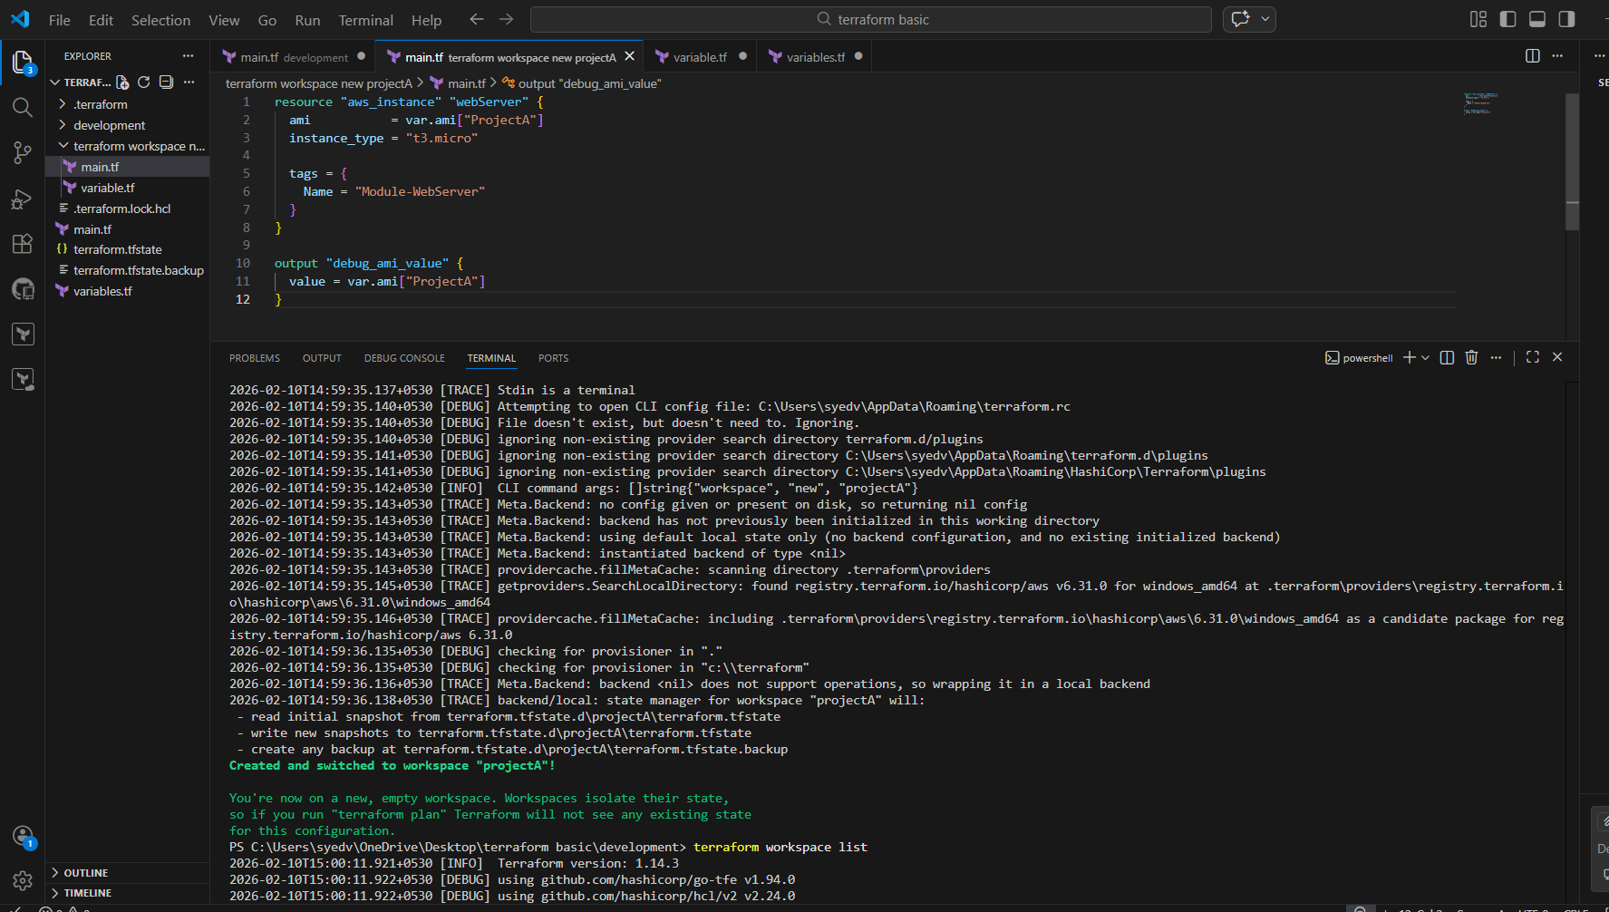
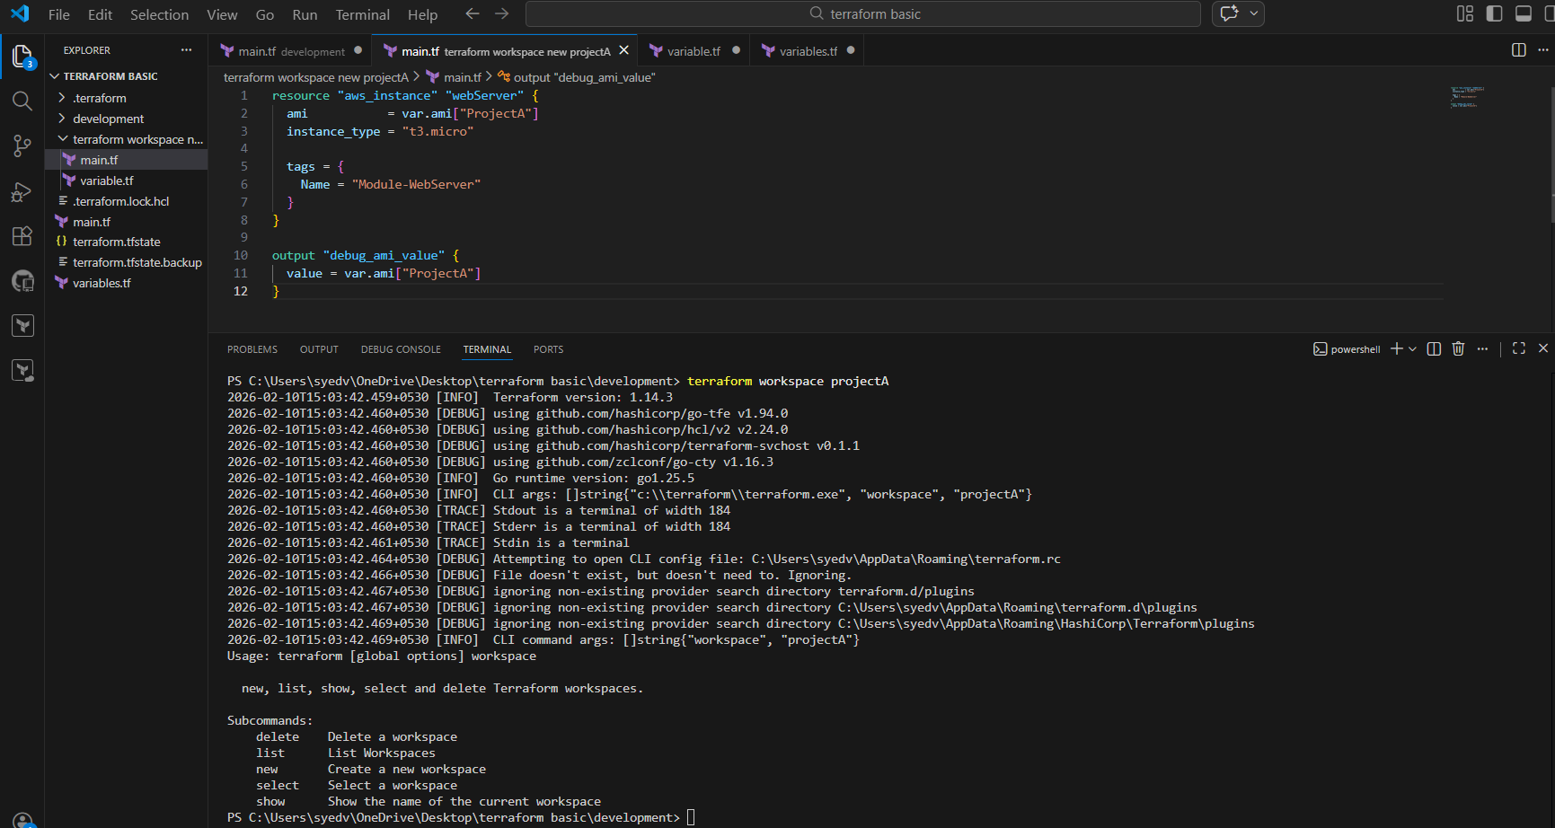
- Set the resources in main.tf
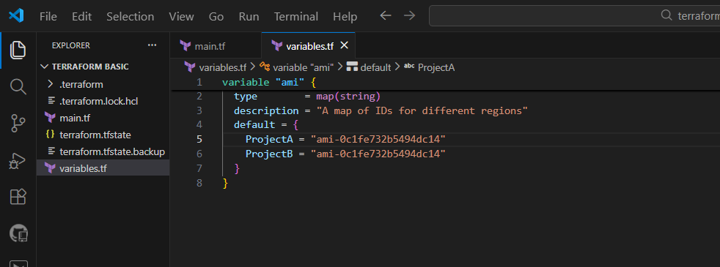
- Set the variables on veriables.tf
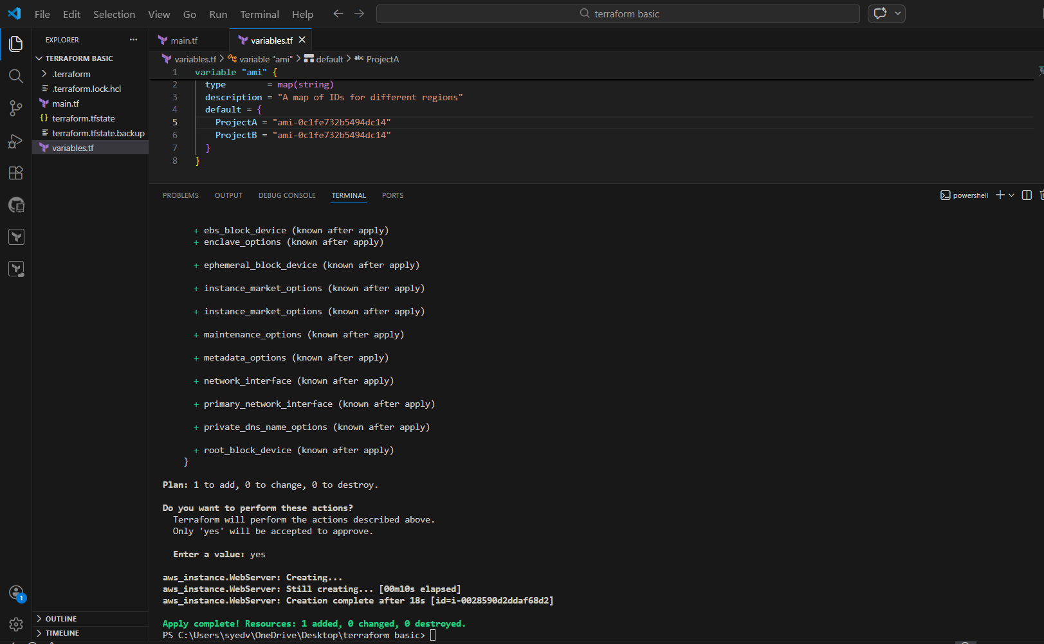
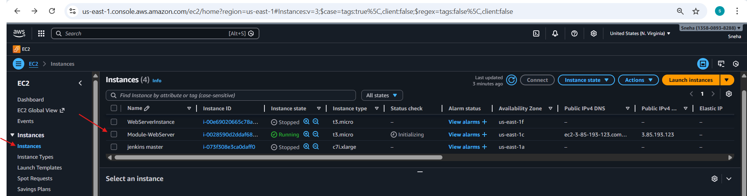

3.Provision EC2, S3, and VPC using Terraform modules.

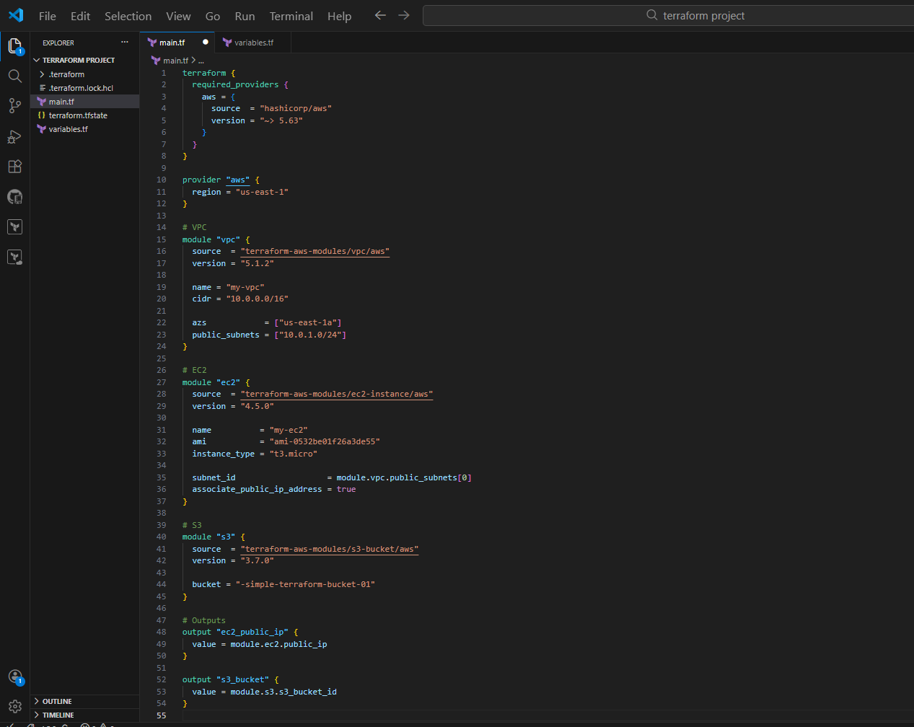
Terraform init
terraform apply
We can see hear 12added and we shall verify if all 3 VPC’s, ec2 and s3 created
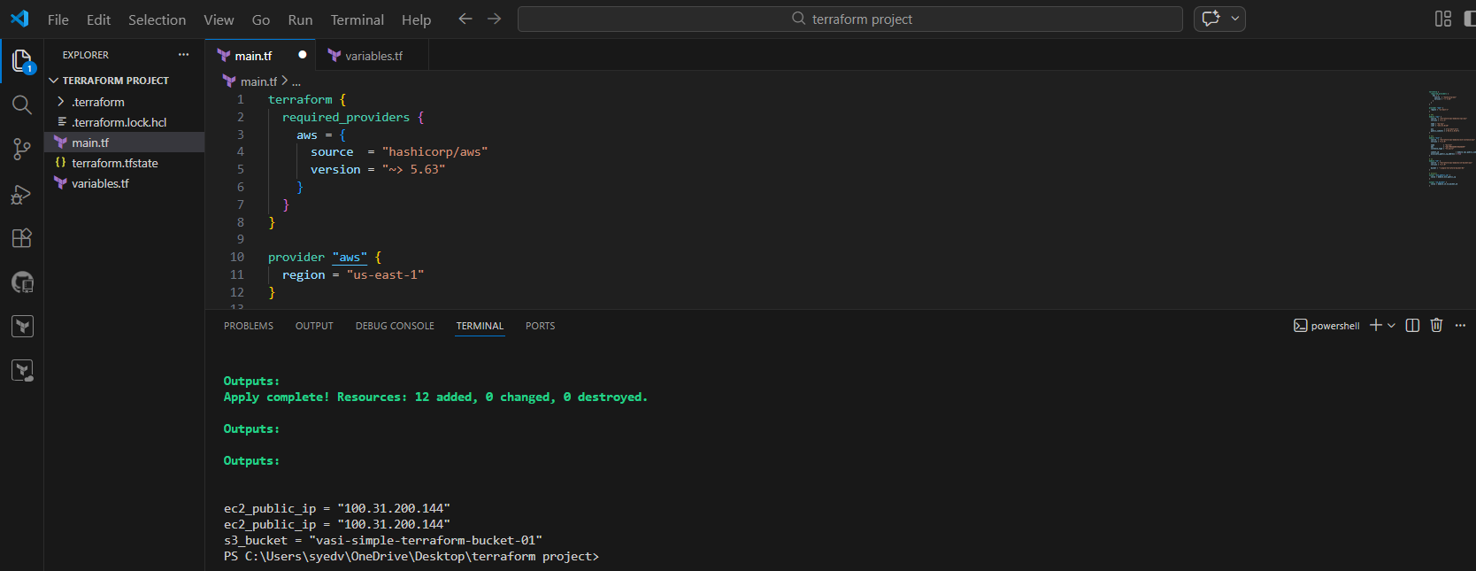

- Ec2
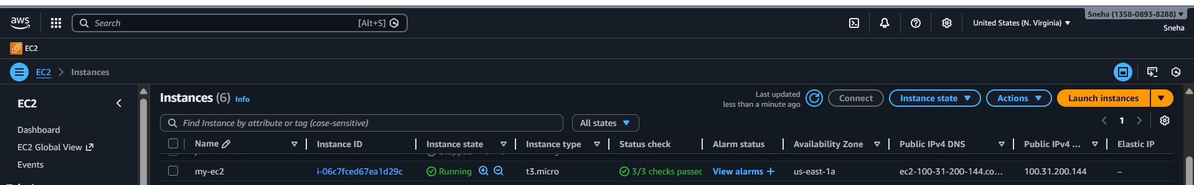

- Vpc
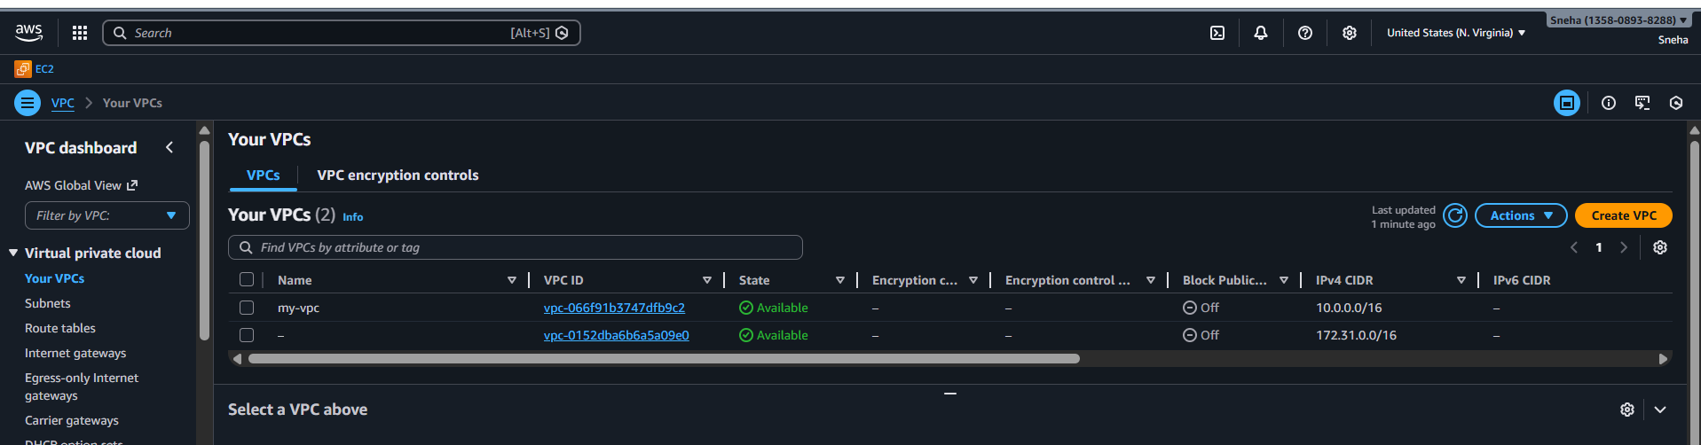
- Subnets
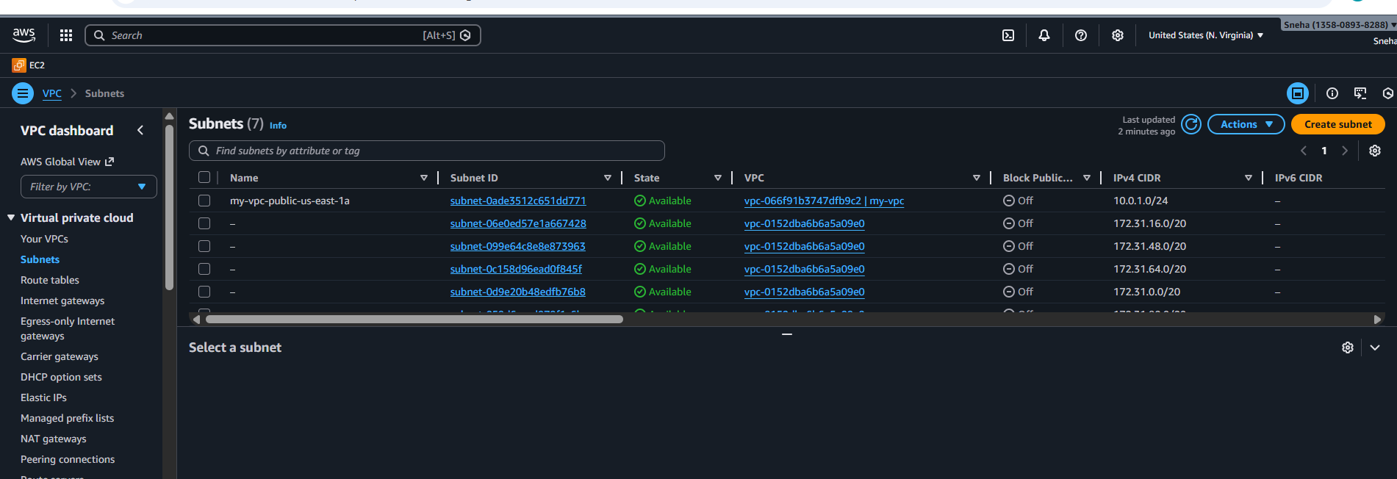
- S3
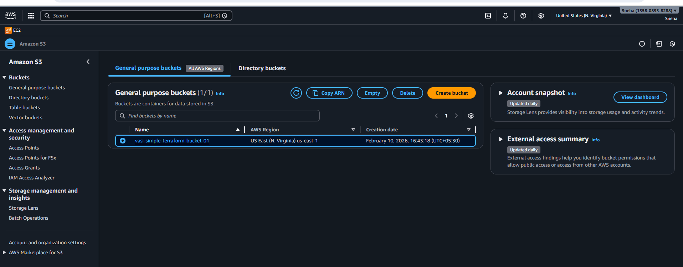

4.Provision EC2 for 3 different environments (Dev, Staging, and Prod) using Terraform workspaces.
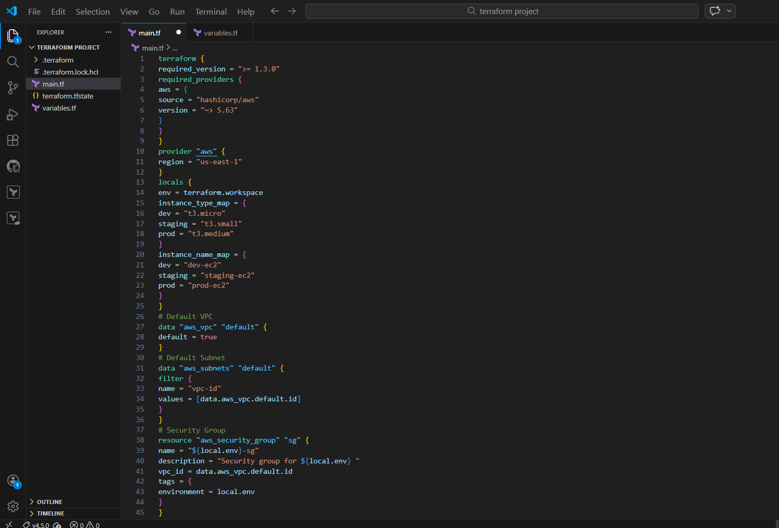
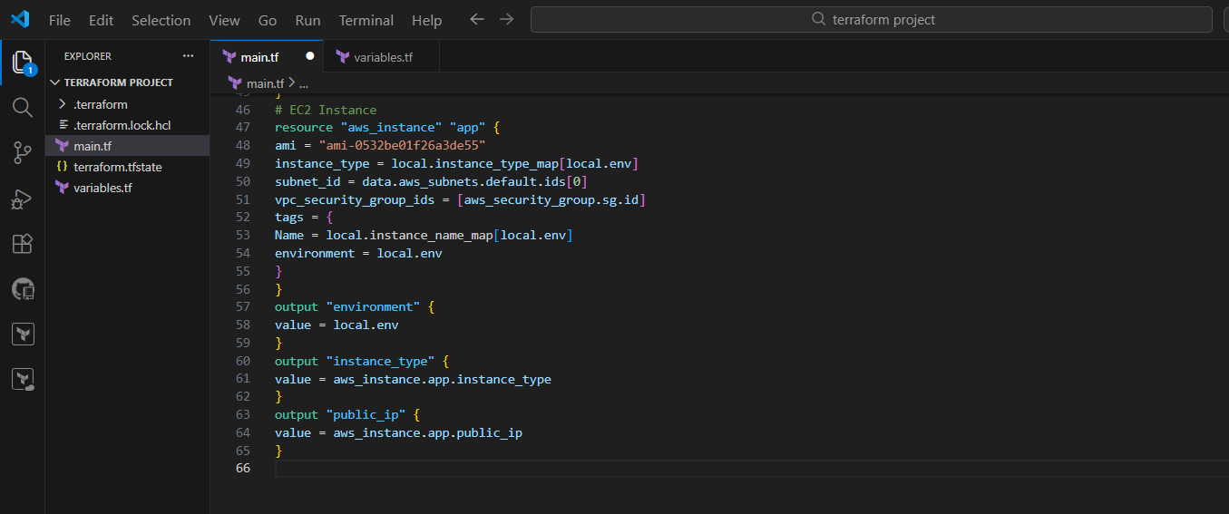

Terraform init
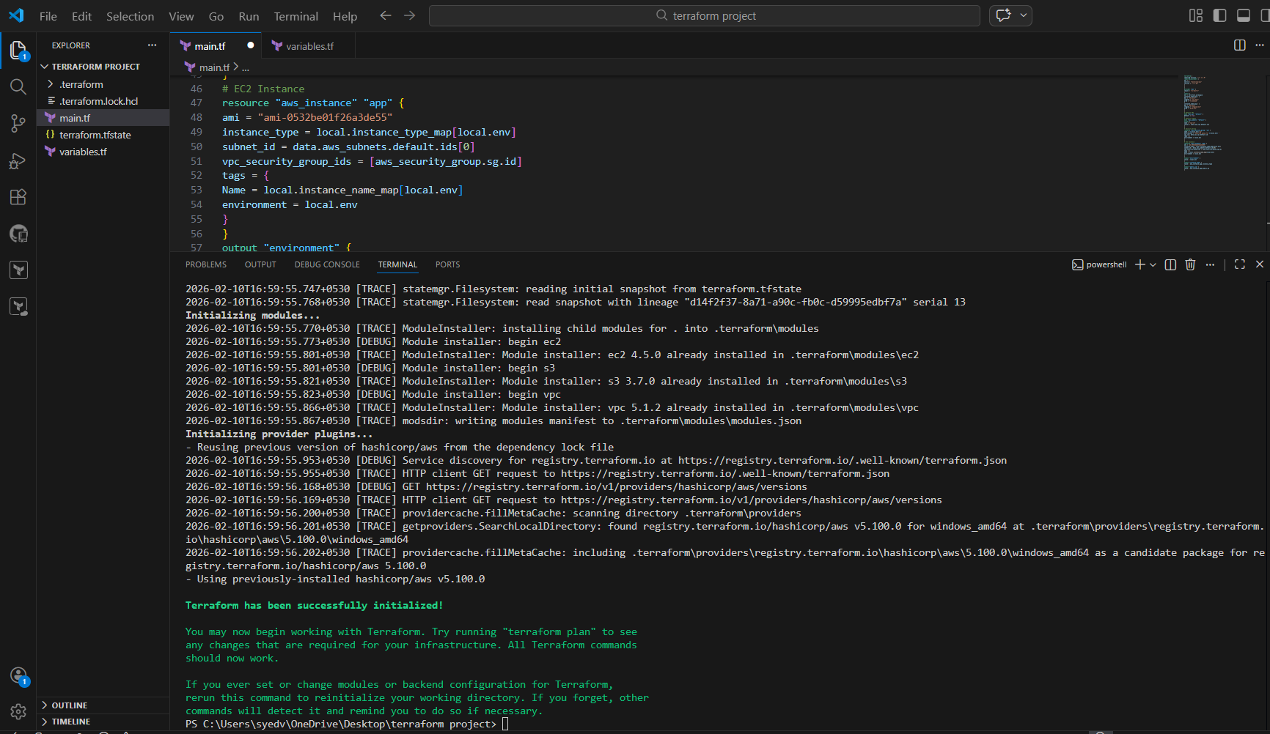
Terraform apply
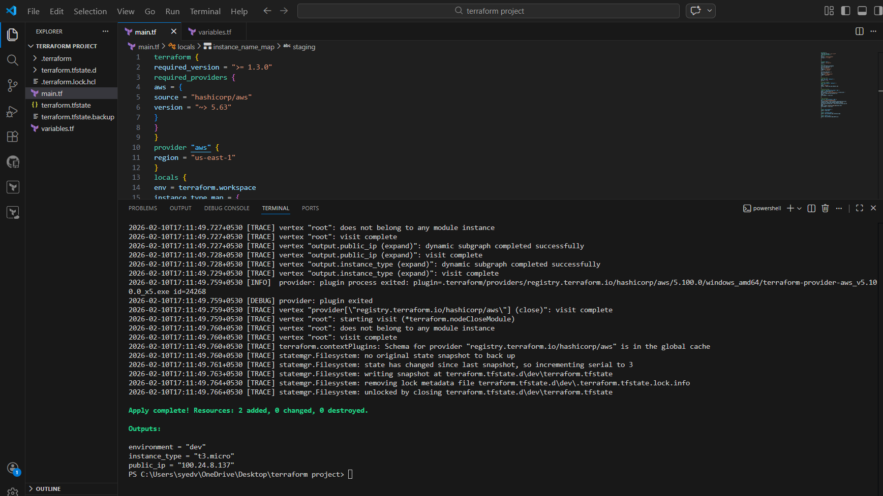

- ec2
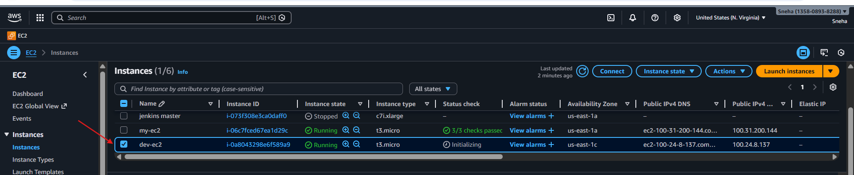
- Security groups
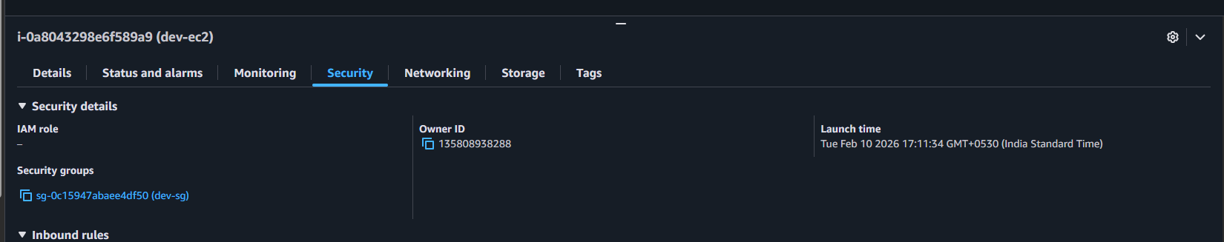

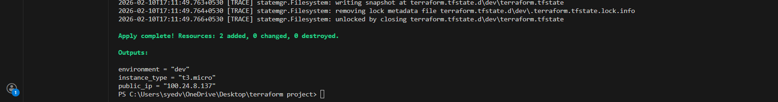

Verify 2nd ec2 instance including with security group
- Prod ec2 created successfully.
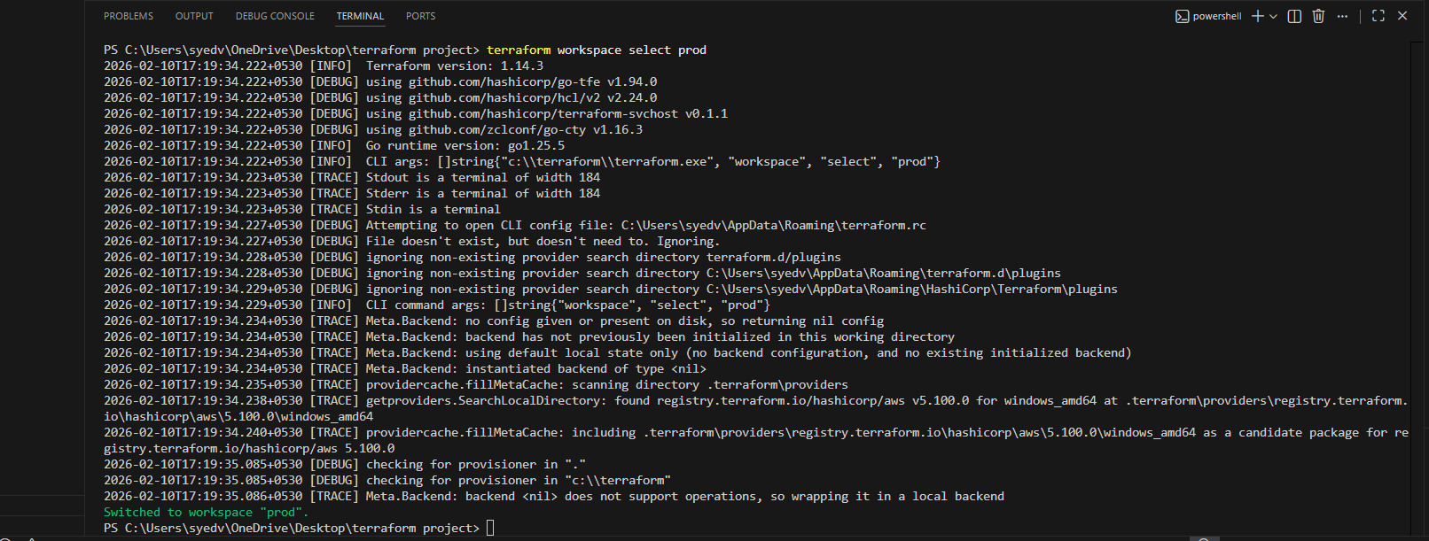
- Success in vs code
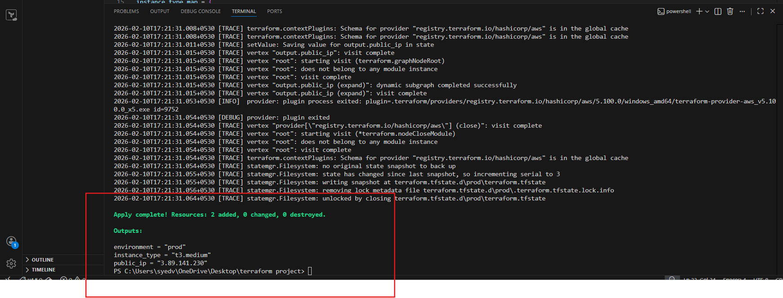
- Verify the aws console
- Ec2 is created successful including with securitygroup
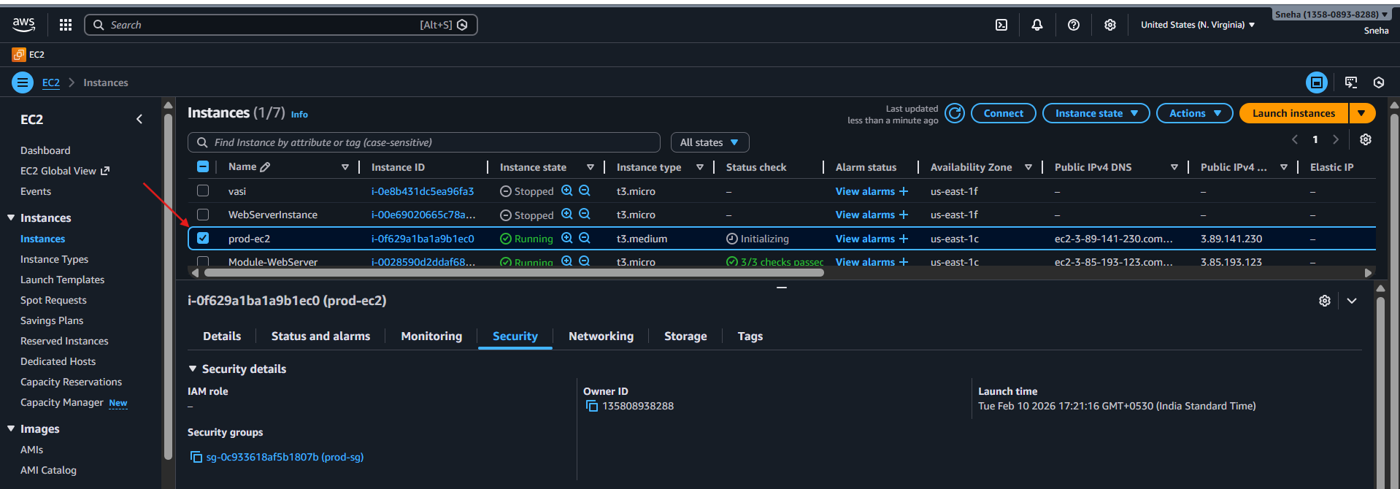
- Let’s verify all environments present in cli
- Command- terraform workspace list
